NAME___________________________________GRADE 8 __________ADMIN NO_______________
ECONOMIC MANAGEMENT SCIENCES: GRADE 8
THE ECONOMY: MARKETS
WHAT IS A MARKET?
A market is defined as a place where buyers and sellers meet. However, a market is not confined to a specific physical location. Owing to technology and the internet, buyers and sellers do not meet face to face to buy and sell goods and services. Buyers demand goods and services at a specific price and sellers supply goods and services.
Did you know?
We know from recorded history that markets developed throughout Africa during ancient times. People came together, at fixed times and at fixed places, to barter the surplus commodities they had. The development of formal markets in South Africa can be traced back to the arrival of Jan Van Riebeeck in 1652. The first market in South Africa was held adjacent to the Castle in Cape Town in the late 1650s and later moved to what is known as Green Market Square.

There are TWO types of markets:
- Goods and service markets
- Factor Market (labour market and financial market)
1. Goods and service markets
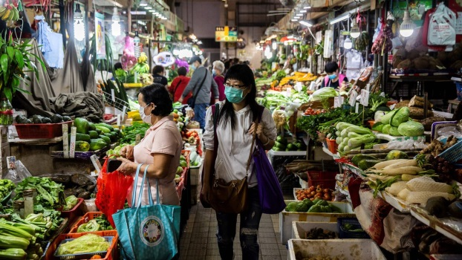
Farmers market, where money is exchanged for goods.
The farmers market in the above picture forms part of a larger market called the goods and services market.
In an economy, all of the places where goods and services are exchanged in economic transactions make up the goods and services market. So, buying goods online and paying for a haircut or a doctors’ appointment are also part of the goods and service market.
Households use their incomes to buy goods and services from businesses and from the government on the goods and services market. These goods and services are finished products that the business has produced using the FACTORS OF PRODUCTION
(Ahhhh, Grade 8s, do you remember the FOUR factors of production?)

2. The Factor Market

The factor market is the market where people buy and sell the factors of productions’ services. It is the market where people buy and sell productive resources. You saw how the goods and services markets is where people buy and sell the outputs of the factors of production, which are finished products. But the factor market is where people buy and sell services of the factors of production themselves- LAND, CAPITAL, LABOUR AND ENTREPRENEURSHIP.

Labour Market

So, how is the factor market different from the goods and services market? Let’s look at labour to understand this.
When a business sells you a car, for example, it sells you a finished product or good.
But when a business buys your labour on the factor market, it is not buying you. Instead, it is buying your services-your ability to work.

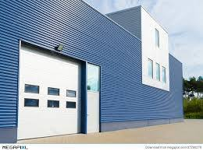
Remuneration for land, such as the land on which this warehouse is built, is rental.
Another example, suppose you won the warehouse in the above picture and you rent it to a business as businesses premises. You are not selling the land to the business-you are just selling a service of the land, which is its ability to allow the business to produce goods there.
When entrepreneurship is exchanged on the factor market, people are not buying and selling the entrepreneurs-they are buying and selling the entrepreneurs’ ideas and the potential of those business ideas to make a profit.
Households are the main buyers on the goods and services market by buying the finished products and services that businesses and the government produce. But businesses and the government are the main buyers on the factor market by buying the labour of households.
Financial Market
The financial markets are markets where people and companies trade financial assets such as stocks and shares. They also trade commodities such as precious metals and agricultural produce at financial markets, and foreign exchange, which are different currencies. An example of a financial market is the Johannesburg Stock Exchange (JSE).
ACTIVITY ONE: Provide an example for each type of market:
PLEASE NOTE YOU NEED TO KNOW EACH OF THE FOLLOWING MARKETS AS WELL
Type of Market | Example
Physical Market
A place where buyers and sellers meet and the desired product is sold and bought for money.
Non-physical Market
Buyers and sellers do not actually meet physically but engage in an exchange via the internet
Auction Markets
The sale of goods where buyers bid against each other to determine the price of the product. The item is sold to the highest bidder.
Factor Market
The factors of production are traded in the factor market. Businesses purchase natural resources, labour and capital. Also known as the resource market.
Wholesale Market
The market for the sale of goods and services to a retailer. That is, a wholesaler receives large quantities of goods from the manufacturer and distributes them to stores, where they are sold to consumers.
Retail Market
Retail is the sail of goods and services from businesses to and end user (called the customer). The good are brought from the producer or wholesaler in large quantities but sold to the customer in small quantities.
Market for Intermediate goods
This is where raw materials are required for the production of other goods and services.
International Currency Market
Participants from around the world are able to buy and sell currency from different countries.
Stock Market Exchange
A Financial market also known as stock exchange, it deals with the buying and selling (trading) of company shares and debentures (FYU :A debenture is a type of debt instrument that is not backed by any collateral and usually has a term greater than 10 years. Debentures are backed only by the creditworthiness and reputation of the issuer.)
Labour Markets
Interaction between workers and employers. Employers compete to hire the best workers.
Black Market
Good and Services are bought and sold illegally

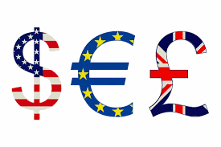
ACTIVITY TWO: Find out the currency for each of the following countries:
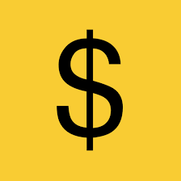  Country | Name of Currency | Symbol
South Africa
United States of America
Britain
France
Germany
Japan
China
India
Botswana
Australia
